UNIT I
AGILE SOFTWARE DEVELOPMENT
1. History and Value of Agile Software Development
1.1 The Beginnings of Software Development as Methodology
Software development, also called software engineering, is a systematic, disciplined and quantifiable approach to the development, operation and maintenance of software.
The field of software development emerged in the 1950s, with operating systems becoming an important area of computing in the 1960s and 1970s.
Waterfall Model
The Waterfall model was the traditional and widely used software development process.
Its main characteristics are:
- Development proceeds through sequential phases.
- One phase is completed before the next phase begins.
- Requirements and design are generally completed before coding.
- It is highly structured and documentation-oriented.
- Changes later in the development process can be difficult and expensive.
The book contrasts Waterfall and Agile as follows:
Waterfall | Agile
Prescriptive | Abstract
Extensive documentation | Minimal documentation
Sequential | Continuous
Formal | Informal
Process focus | Communication focus
Gradual change | Rapid change

2. Rise of Agile Software Development
At the beginning of the 21st century, technology products—particularly websites and Internet-based applications—were experiencing rapidly changing customer requirements.
Development teams needed to:
- Respond quickly to new requirements.
- Deliver new features faster.
- Obtain customer feedback frequently.
- Remain competitive in a rapidly changing market.
This created the need for iterative software development, which eventually contributed to the rise of Agile.
What is Agile?
Agile is an overarching term covering iterative approaches to software development that follow the values of the Agile Manifesto.
It is not one specific methodology.
Instead, Agile provides a collection of:
- Tools
- Techniques
- Practices
- Methods
that help organizations focus on:
- Efficiency
- Collaboration
- Quality
- Customer value
- Adaptability
Examples include:
- Scrum
- Extreme Programming (XP)
- Crystal
- Feature-Driven Development (FDD)
- Lean Software Development
- Kanban
- Dynamic Systems Development Method (DSDM)

3. Agile Manifesto
The Manifesto for Agile Software Development was created in 2001 at a meeting of 17 software development practitioners in Snowbird, Utah.
The participants were interested in lightweight development approaches and wanted an overarching term for these approaches. The term Agile was selected.
Four Values of Agile Manifesto
- Individuals and Interactions over Processes and Tools
- Working Software over Comprehensive Documentation
- Customer Collaboration over Contract Negotiation
- Responding to Change over Following a Plan

1. Individuals and Interactions over Processes and Tools
Agile gives greater importance to:
- People
- Communication
- Teamwork
- Trust
- Collaboration
rather than simply following processes or depending on sophisticated tools.
Face-to-face communication is particularly valuable.
2. Working Software over Comprehensive Documentation
- The objective is to produce working software that customers can actually use and evaluate.
- Instead of spending excessive time creating static documents, Agile teams develop usable versions of the product and obtain feedback.
3. Customer Collaboration over Contract Negotiation
- Customers should actively participate in development.
- Instead of simply agreeing to a fixed contract at the beginning, Agile encourages:
- Regular customer interaction
- Feedback
- Requirement adjustment
- Collaboration
4. Responding to Change over Following a Plan
- Agile accepts that requirements will change.
The team should therefore adapt to changing:
- Customer needs
- Market conditions
- Business priorities
- Technology
rather than rigidly following an initial plan.
Important point
- The word “over” does not mean that the item on the right is useless.
- For example, Agile does not mean:
- Documentation is unnecessary.
- It means that when there is a conflict, Agile gives greater value to the item on the left.
- The book specifically emphasizes this distinction.

4. Twelve Principles of Agile
The book gives the following 12 principles:
- Customer satisfaction through early and continuous delivery of valuable software.
- Welcome changing requirements, even late in development.
- Deliver working software frequently, preferring shorter timescales.
- Business people and developers work together daily.
- Build projects around motivated individuals and trust them.
- Face-to-face conversation is the most effective communication method.
- Working software is the primary measure of progress.
- Agile promotes sustainable development.
- Continuous attention to technical excellence and good design enhances agility.
- Simplicity—maximizing the amount of work not done—is essential.
- The best architectures, requirements and designs emerge from self-organizing teams.
- Teams should regularly reflect and improve their effectiveness.
Easy way to remember
Customer → Change → Frequent delivery → Collaboration → Motivation → Communication → Working software → Sustainable pace → Technical excellence → Simplicity → Self-organization → Continuous improvement

5. Organizational Culture Considerations with Agile
The important idea is:
- Moving from Waterfall to Agile is not simply a matter of introducing new tools.
- It requires an organizational cultural transformation.
- The authors explain that they initially thought Agile could be implemented by training people in tools and methodologies.
- They later realized that organizations had to undergo a cultural shift.
- Agile transformation is therefore described as a journey rather than a destination.

Why organizational culture matters
Agile requires changes in:
- Communication
- Decision-making
- Team structure
- Management style
- Customer involvement
- Responsibility
- Trust
- Planning
- Response to change
Agile transformation from 3 viewpoints:
1. Team member
2. Manager
3. Executive

Team Member Viewpoint
Under Agile, team members experience greater:
- Collaboration
- Responsibility
- Communication
- Adaptability
- Participation in decisions
- Self-organization
Agile teams are expected to work collaboratively rather than simply receiving detailed instructions.
Major cultural change
- Traditional environment:
Manager → gives instructions → employee executes
- Agile environment:
Team → collaborates → makes decisions → delivers → receives feedback → improves
Face-to-face communication is especially emphasized in Agile.

6. Manager's Viewpoint
Managers also need to change their management style.
A manager must:
- Trust the team.
- Help remove obstacles.
- Support employees.
- Develop team members.
- Address staffing and resource issues.
- Facilitate successful Agile implementation.
Management style based on constant monitoring and lack of trust can struggle with Agile adoption.
Traditional manager vs Agile manager
Traditional approach | Agile approach
Controls employees | Trusts team
Gives detailed instructions | Enables self-organization
Focuses on submission | Focuses on results
Heavy supervision | Coaching/support
Fixed plans | Adaptation
Individual responsibility | Team responsibility

7. Executive Viewpoint
Executives have an important role because they control:
- Budget
- Resources
- Organizational priorities
- Major decisions
- Agile requires executives to accept evolving requirements rather than demanding a complete and perfectly accurate plan before development starts.
- Instead of attempting to predict everything:
Small delivery → inspect → learn → adjust → next delivery
- This incremental approach provides greater predictability through actual results.
Wrong Metrics
- Inappropriate metrics can damage Agile adoption.
Examples include:
- Comparing actual time with estimated time.
- Comparing the velocity of different teams.
Velocity is a planning/prediction tool, not a productivity comparison between teams.
Agile success should emphasize:
- Customer satisfaction
- Frequent delivery of working software
- Continuous learning

6. Understanding Different Types of Agile
There is no single Agile formula.
- Organizations can select and combine methods according to their needs.
Method | Main emphasis | Founder/Origin
XP | Efficiency, customer focus, feedback, quality | Kent Beck
Scrum | Teaming and organizing work | Jeff Sutherland, Ken Schwaber
FDD | User-focused features | Jeff De Luca
DSDM | Structured rapid development | DSDM Consortium
Lean | Eliminating non-value work | Mary & Tom Poppendieck
Kanban | Workflow visualization and flow | David J. Anderson
Crystal | People, communication and appropriate process rigor | Alistair Cockburn

Type 1: Extreme Programming — XP
- Extreme Programming originated at Chrysler Motors in 1996 during the Chrysler Comprehensive Compensation System (C3) payroll project, led by Kent Beck.
- Its popularity increased after Beck's 1999 book “Extreme Programming Explained”.
Main characteristics of XP
- Frequent releases
- Short development cycles
- Pair programming
- Regular builds
- Integration testing
- High quality
- Avoiding code breakage
- Simple code
- Rapid feedback
Pair Programming
Two programmers work together on the same code.
Benefits include:
- Real-time code review
- Knowledge sharing
- Cross-training
- Improved code quality
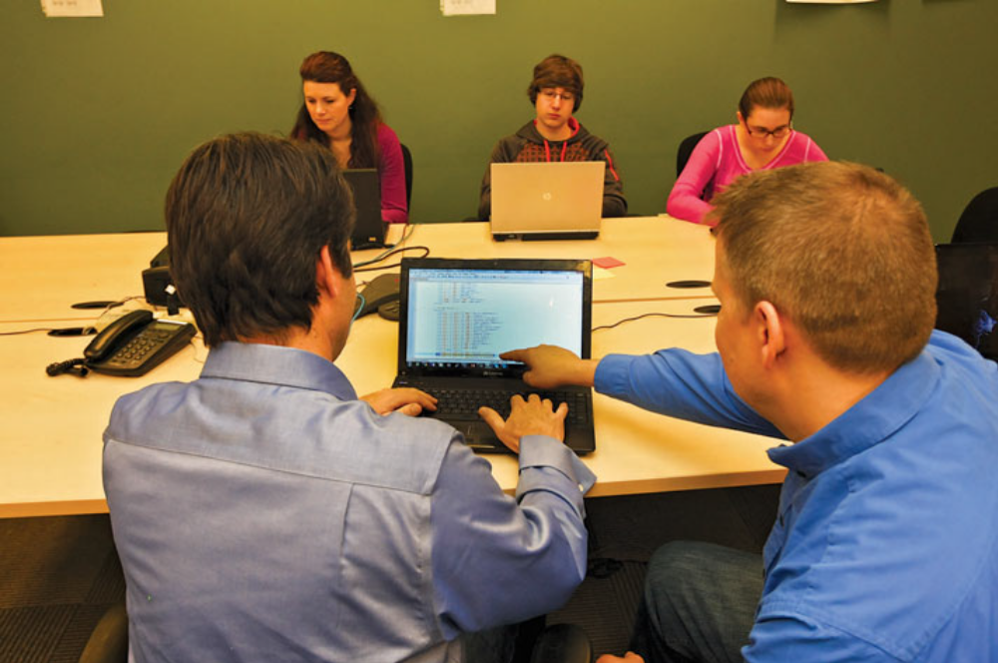
Test-Driven Development
- XP relies heavily on automated unit testing through TDD.
The idea is to use tests continuously during development rather than leaving testing until the end.
Four basic XP values
- Simplicity
- Communication
- Feedback
- Courage

Type 2: Scrum
Scrum was developed by Jeff Sutherland, Ken Schwaber in 1990s.
Scrum emphasizes:
- Teamwork
- Organizing work
- Prioritization
- Time-boxed development
- Frequent delivery
- Scrum divides work into sprints (Timebox).
- Work is grouped into chunks that can be completed in approximately 1–6 weeks.
- The objective is to have functionality ready for delivery at the end of the sprint.
Product Backlog
- The Product Owner maintains a prioritized list of requirements called the Product Backlog.
- Requirements are expressed using user stories.
Daily Scrum
- The Scrum team holds a daily stand-up meeting.
The three basic questions are:
- What have I done since yesterday?
- What am I doing today?
- Are there any roadblocks?
The meeting is normally short, around 15 minutes.
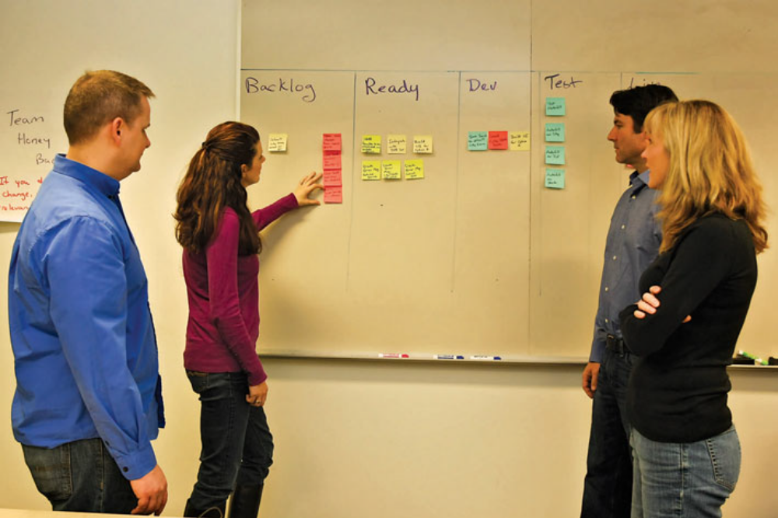

Type 3: Feature-Driven Development — FDD
- FDD was conceived by Jeff De Luca in 1997.

Its central idea is:
- Plan and develop around specific features that address customer requirements.
- It emphasizes incremental delivery of user-focused functionality.
FDD activities are
- Create the model
- Develop the feature list
- Order features
- Assign features/classes
- Develop and deliver features
- FDD uses short iterations, with features commonly developed in two-week iterations.
Main focus
Customer requirement → Feature → Design → Build → Working feature

Type 4: Dynamic Systems Development Method- DSDM
- DSDM is a structured framework for rapid project development.

DSDM is
- Timeboxing
- Prototyping (Complete Ideology)
- MoSCoW prioritization
- Structured project phases
The four major phases include:
- Feasibility
- Functional model iteration
- Design and build iteration
- Implementation
- During implementation, users accept the product, receive training, and the team verifies whether business objectives have been achieved.
DSDM has nine principles
1. Active user involvement is critical for any project.
2. Teams must be empowered to make decisions.
3. Teams need to focus on frequent product delivery.
4. Standards must be in place for an approved deliverable.
5. All development must be done iteratively and delivered incrementally.
6. Any change introduced during development must be reversible.
7. Product requirements are baselined as high-level themes rather than low level
changes or improvements.
8. Product testing is performed throughout the project life cycle.
9. Team interactions are collaborative and cooperative.

Type 5: Lean Software Development
Lean Software Development comes from Lean manufacturing.
The basic idea is:
- Create customer value and eliminate waste.
- Anything that does not contribute to customer expectation should be examined as waste.
Seven Lean Principles
1. Eliminate waste
- Remove activities that do not add customer value.
2. Amplify learning
Learn through:
- Testing
- Prototyping
- Customer feedback
3. Decide as late as possible
- Wait for sufficient facts instead of making assumptions too early.
4. Deliver as fast as possible
- Focus on speed to market.
5. Empower the team
- Allow team members to make important decisions.
6. Build integrity in
- Ensure the different pieces work together as a whole.
7. See the whole
- Consider the complete product experience rather than isolated components.

Type 6: Kanban Method
- Kanban was developed by David J. Anderson and is associated with Just-in-Time software delivery.
- The Japanese word Kanban is loosely translated as “signboard.”
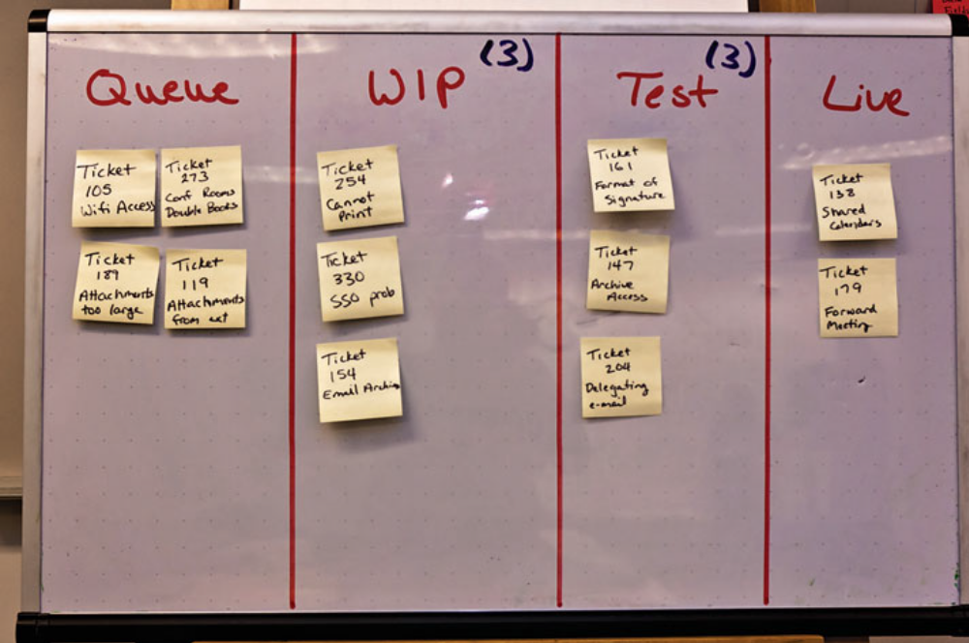

It provides a visual system showing:
- What should be produced?
- When it should be produced?
- How much should be produced?
Kanban Board
- A Kanban board visually represents workflow.
A simple example:
To Do → In Progress → Testing → Done
- The board makes work visible.
Pull system
- Kanban uses a pull approach.
- New work is pulled into the workflow when capacity becomes available, rather than pushing unlimited work into the system.

3 key Kanban principles
- Foster leadership at all organizational levels.
- Start with what you know.
- Kanban is intentionally less prescriptive and recognizes that organizations differ.

Type 7: Crystal Family
The Crystal Family was developed by Alistair Cockburn.
Its major focus is:
- People
- Communication
- Team dynamics
- Appropriate process rigor
The important idea is that one process does not fit every project.
Instead, the amount of structure should be adjusted according to:
- Team size
- Project characteristics
- Organizational dynamics
- Product characteristics
Crystal uses colors to represent different levels of complexity, risk, and team size
- Crystal Clear: For small teams of 2 to 8 people on low-risk projects.
- Crystal Yellow: Fits teams of 7 to 20 people.
- Crystal Orange: Supports larger groups of 21 to 40 people with moderate complexity.
- Darker colors (Red, Maroon, etc.): For larger, highly complex systems and high-criticality projects.
Key principle
Choose the method according to the situation rather than forcing every project into one methodology.

16. Agile Certification
There is no certification process for an entire organization to become an officially “Agile-certified organization.”
However, individual practitioners can obtain Agile certifications.

Examples discussed include:
- PMI-ACP — Agile Certified Professional
Offered by the Project Management Institute (PMI), this exam covers multiple approaches including Scrum, Kanban, Lean, and XP.
- Certified Scrum Master (CSM)
Focuses on helping a team follow Scrum rules, removing obstacles, and facilitating daily collaboration.
- Certified Scrum Product Owner (CSPO)
Focuses on managing the product backlog, defining user stories, and maximizing the business value of the product.
- Certified FDD Practitioner
Validates hands-on skills in building domain models and developing features incrementally in short iterations.
- Certified FDD Project Manager
Focuses on the administrative leadership, reporting, and resource planning needed to run larger FDD-based software initiatives.
- Certified Kanban Practitioner
Validates your ability to visualize workflow, limit work-in-progress (WIP), and optimize delivery speed using Kanban boards and Lean principles.

17. Case Study : Implementing Tools and Techniques at Cayman Design
- Cayman Design is a company used to demonstrate Agile implementation.
- It is a web-design company that expanded into mobile applications and had a development team in Pune, India, while most of its team remained in Austin.
Why Cayman Design adopted Agile?
Competitors were:
- Delivering products faster
- Using Agile
- Achieving increased customer satisfaction
Cayman therefore decided to introduce Agile methods.
Implementation
Cayman Design:
- Sent key employees for Agile training.
- Hired or invited an expert in Agile software development
- Selected tools from:
  - XP
  - Scrum
  - Kanban
- Installed Kanban boards.
- Created pairing stations (2 programmers).
- Formed Scrum teams.
- Created a code repository capable of producing daily builds.
- Used video conferences, email and instant messaging for global communication.

